**Submitted by: Submitted to:**

**NAME: Rahul Gusain Hitesh Kumar Sharma**

**SAP: 500084143**

**ROLL NO.: R214220900**

**BATCH: 1 DevOps**

# Build and Release Management

**LAB EXERCISE 1**

**Aim:**

1. **Create a Java Project using Maven.**
2. **Run the following maven goals on this project**

* **Clean**
* **Compile**
* **Test-Compile**
* **Install**

1. **Create a Java Project using Maven**

Step 1 :- First check the version of java and Apache Maven on your machine using terminal .

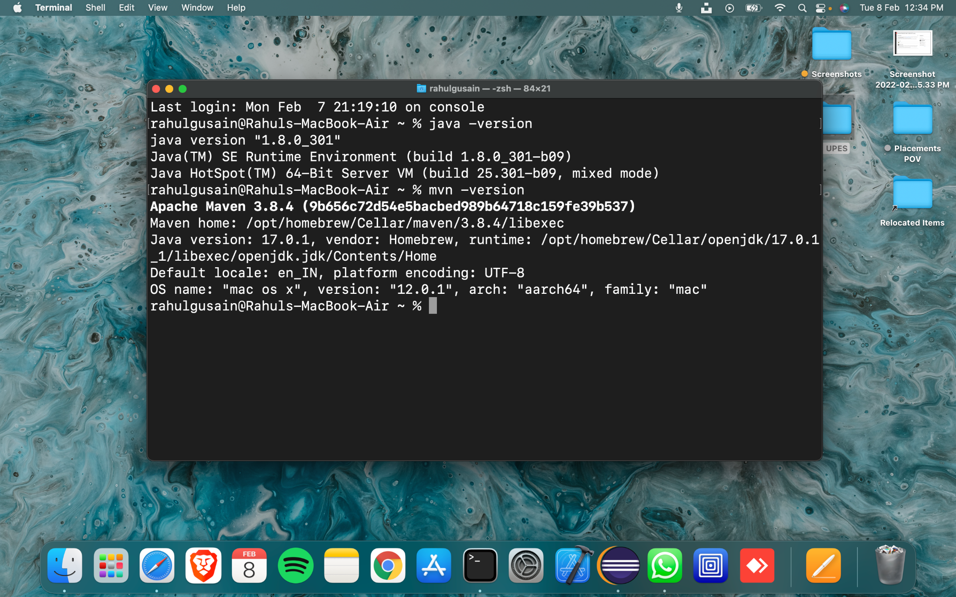

Step 2 :- Install Eclipse and then go to File and then click on new and then click on others.

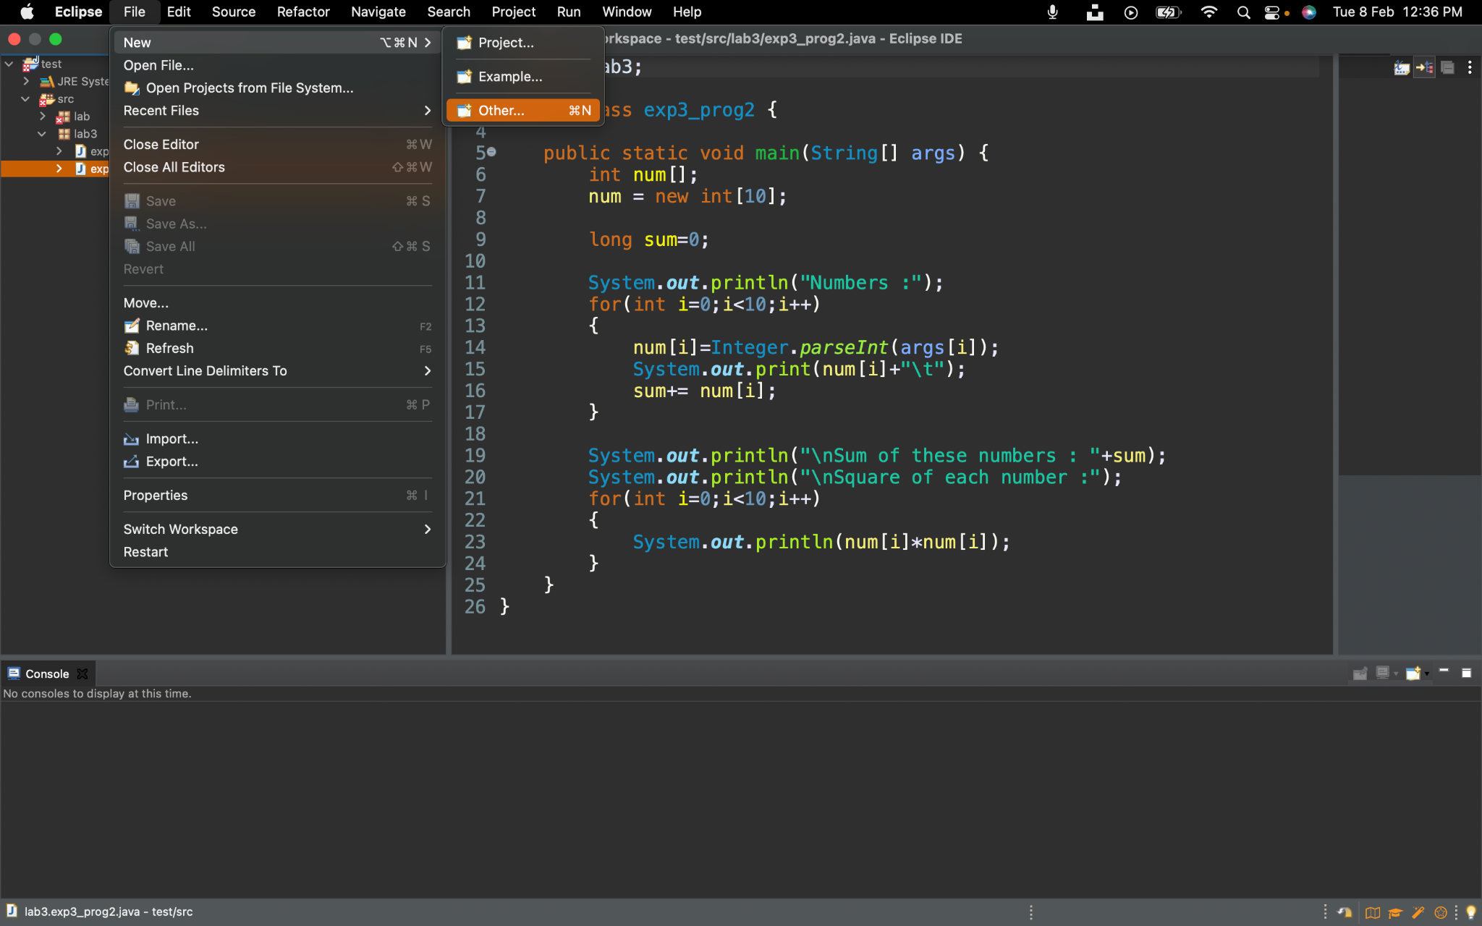

Step 3 :- Write maven on bar and then click on Maven project and then click on next.

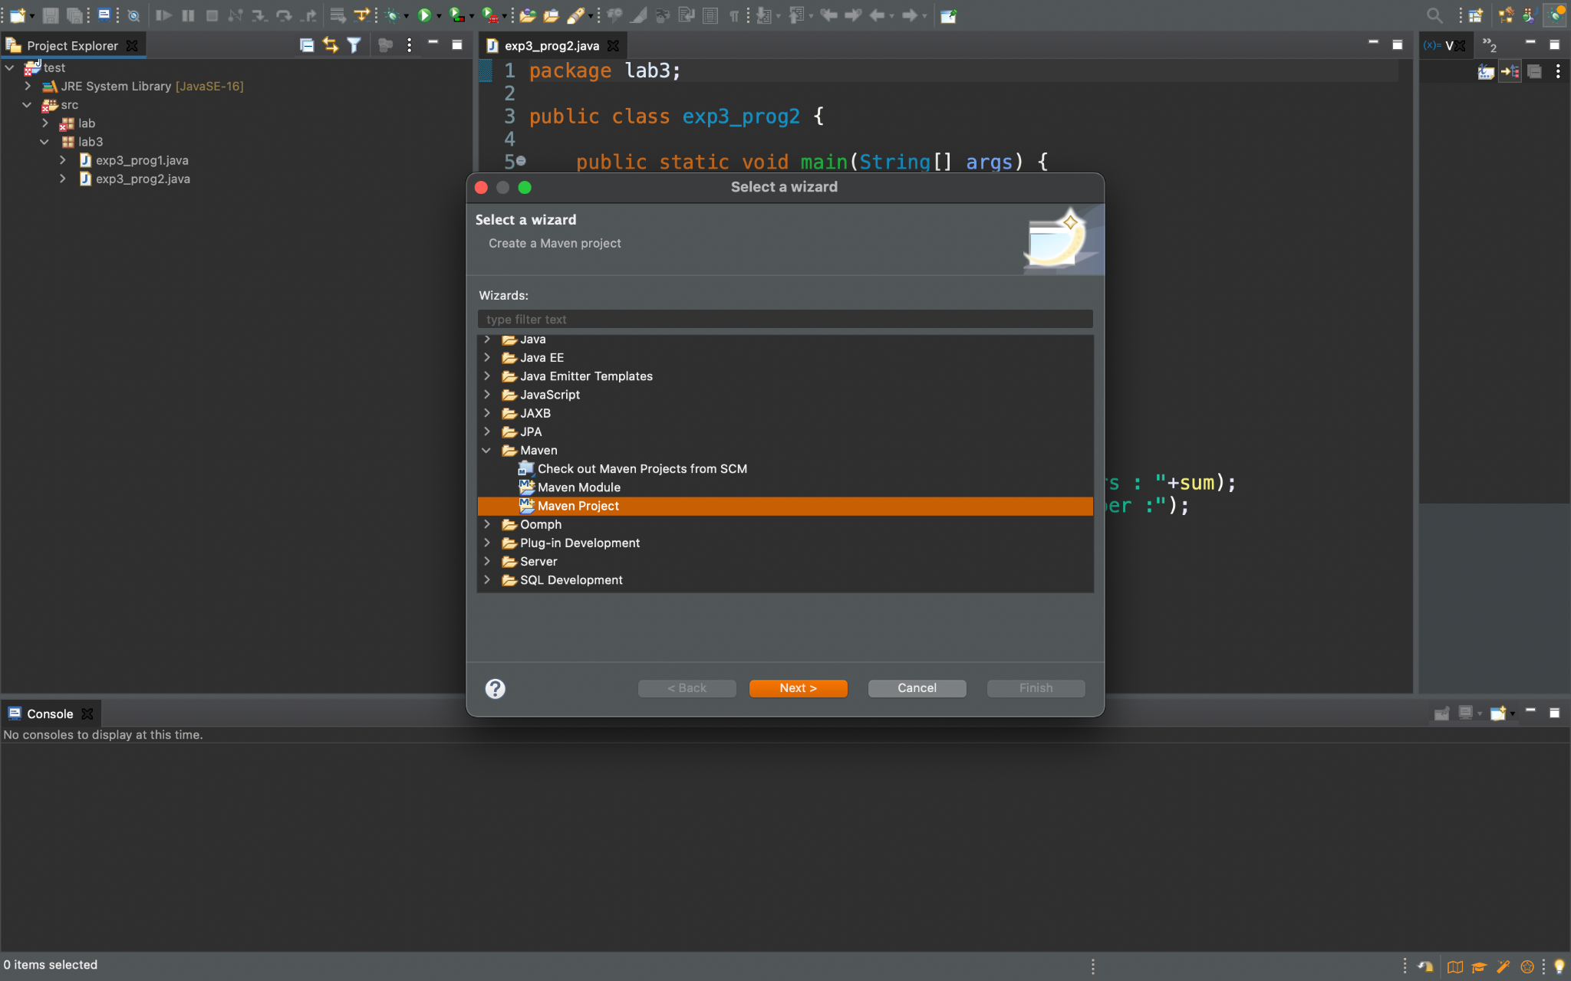

Step 4:- Check the two boxes and click on Next.

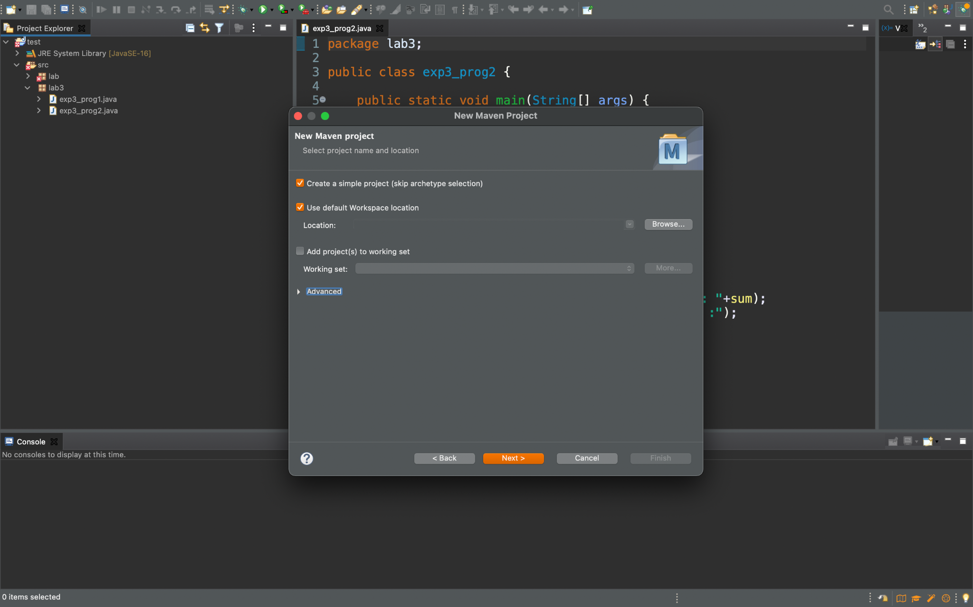

Step 5:- Now do the nomenclature of Group id, Artifact id, and Name of the Project.

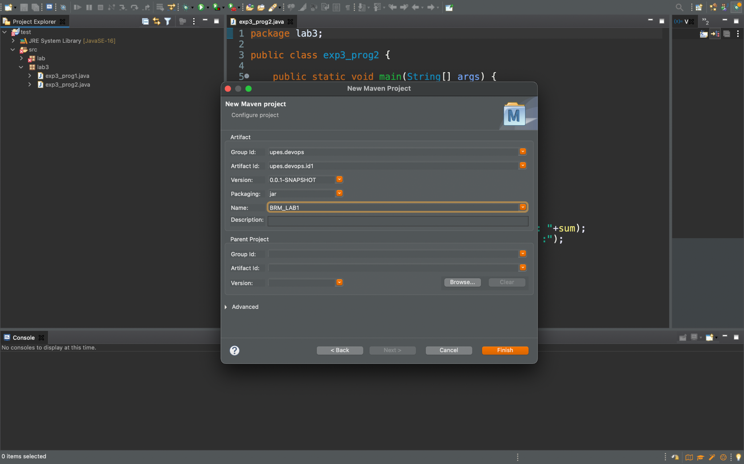

Step 6:- Right-click on the project and create Java Class and then give a name to it.

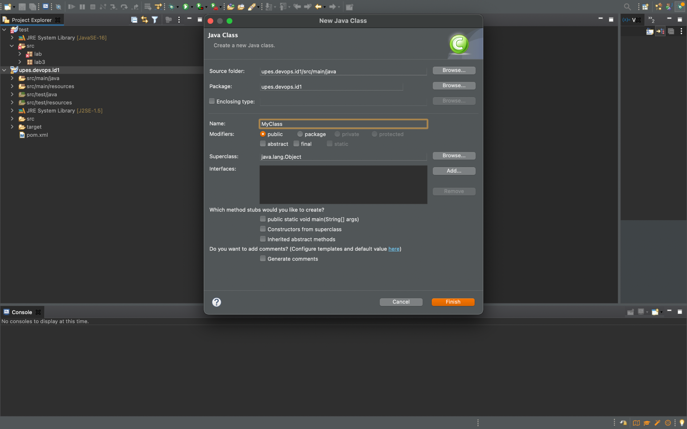

Step 7:- Write the Code and Compile it.

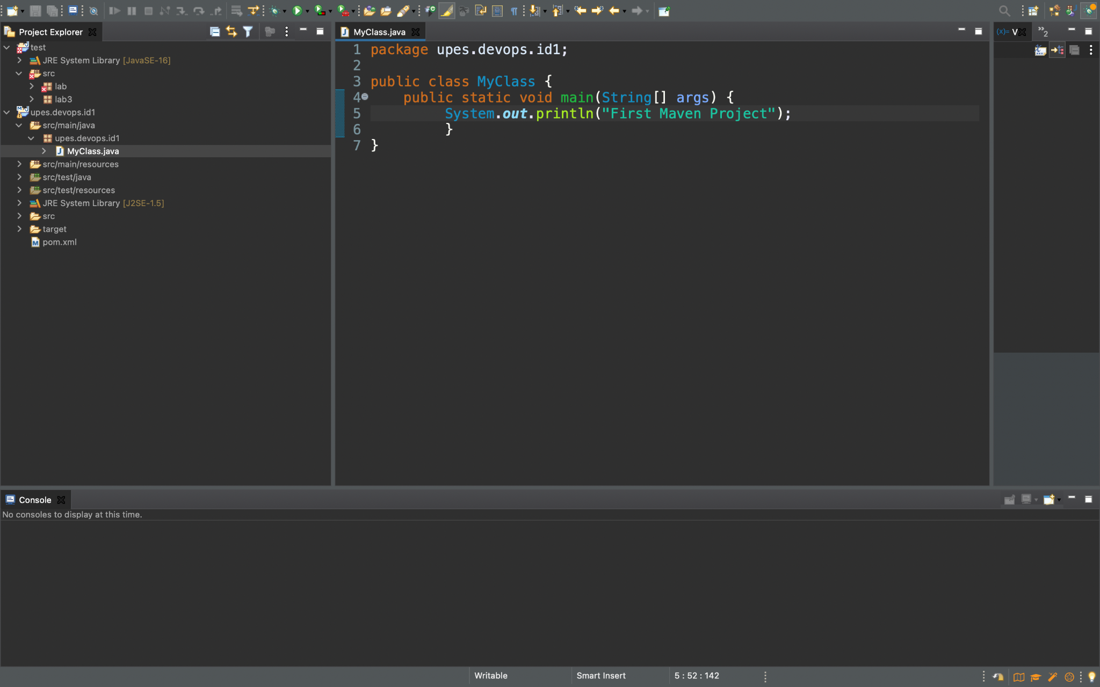

This is our first Maven project.

1. **Run the following maven goals on this project**

* **Clean**
* **Compile**
* **Test-Compile**
* **Install**

1. **Clean**

**Step 1:-** Right Click on the project and then click on Run as and then on maven with three dots.

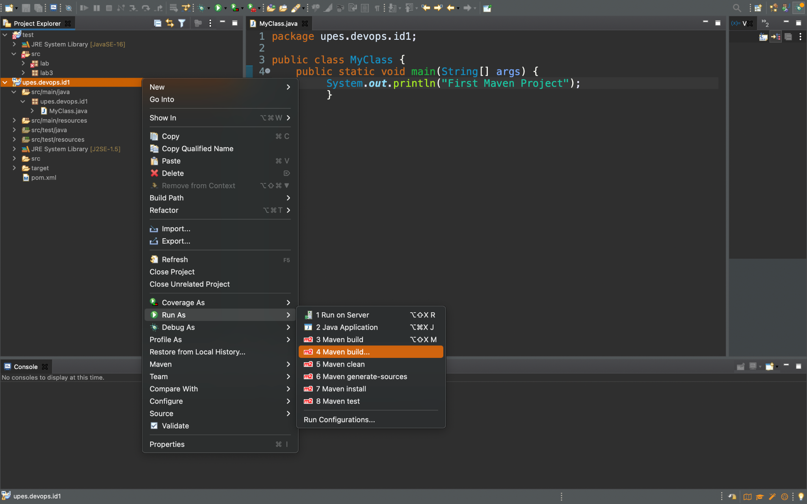

**Step 2:-** Write clean as Goal and click on Run.

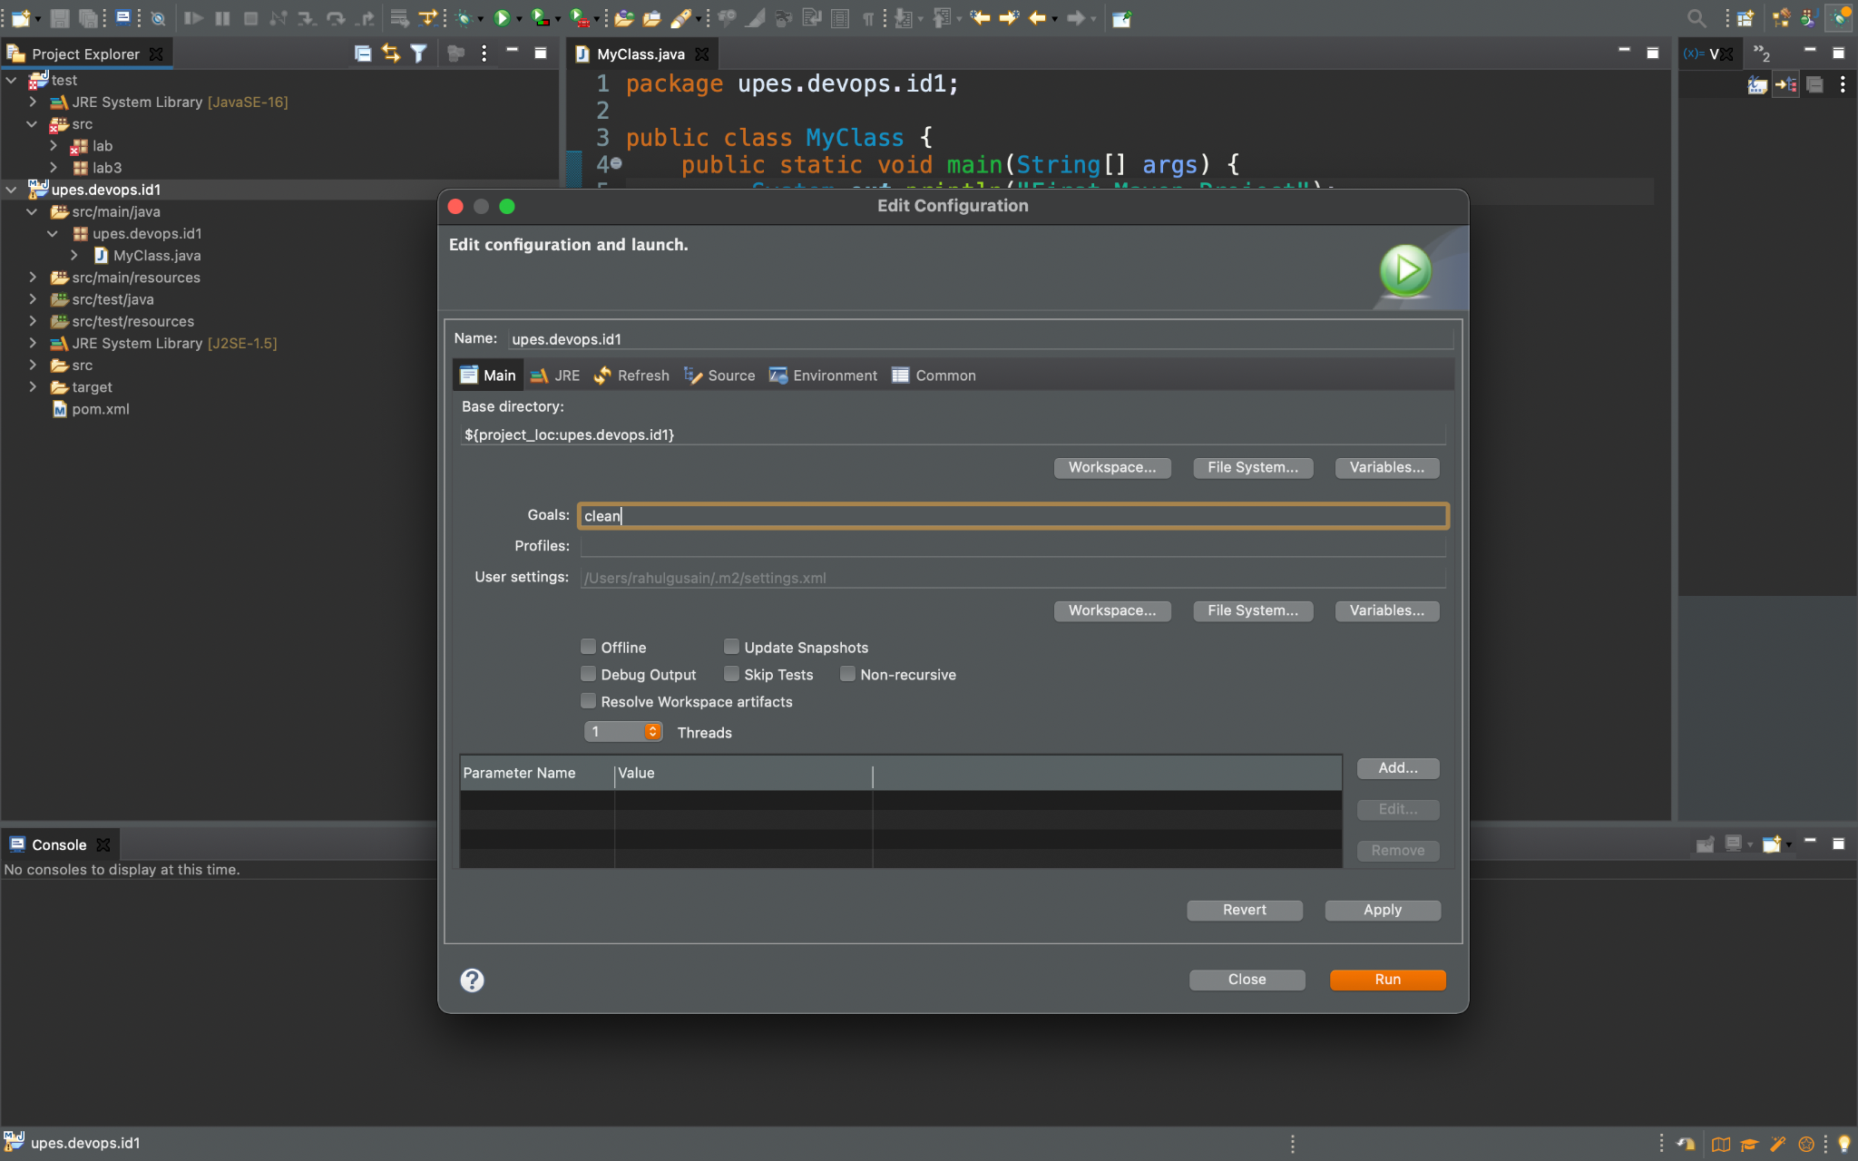

**Step 3 :-** Finally Clean goal is running and it is showing build success.

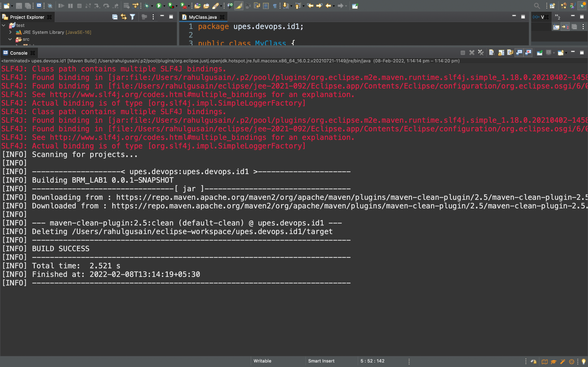

**B) Compile**

Similarly, we will set compile as a goal and it executes BUILD SUCCESS

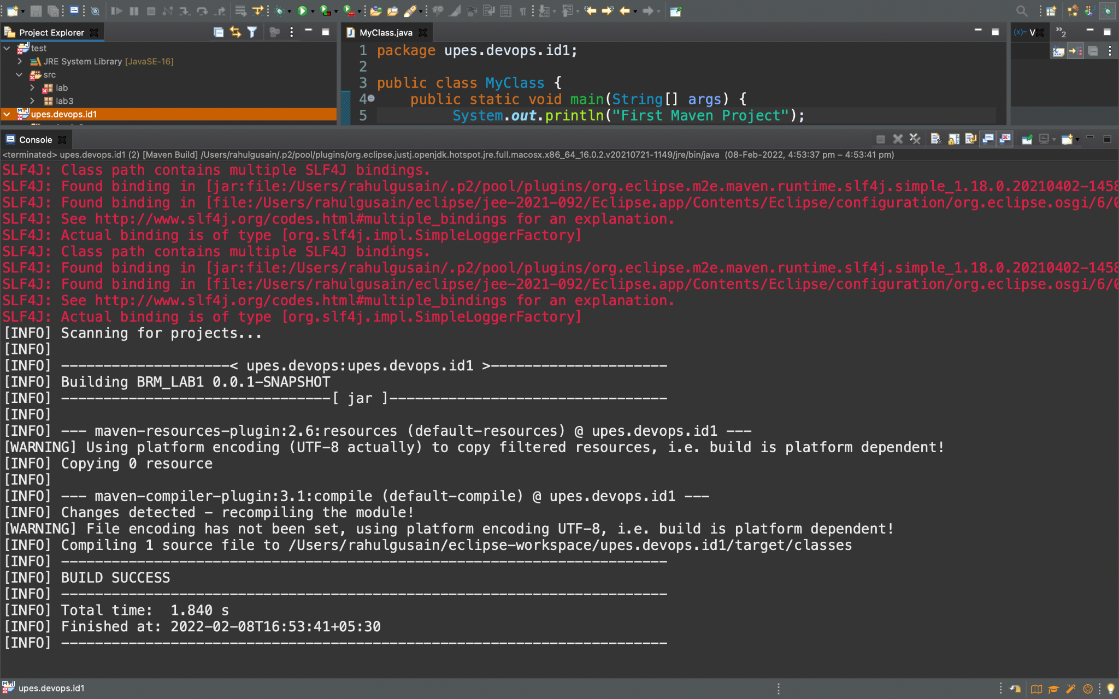

**C) Test-Compile**

Similarly, we will set​​ test- compile as a goal and it executes BUILD SUCCESS

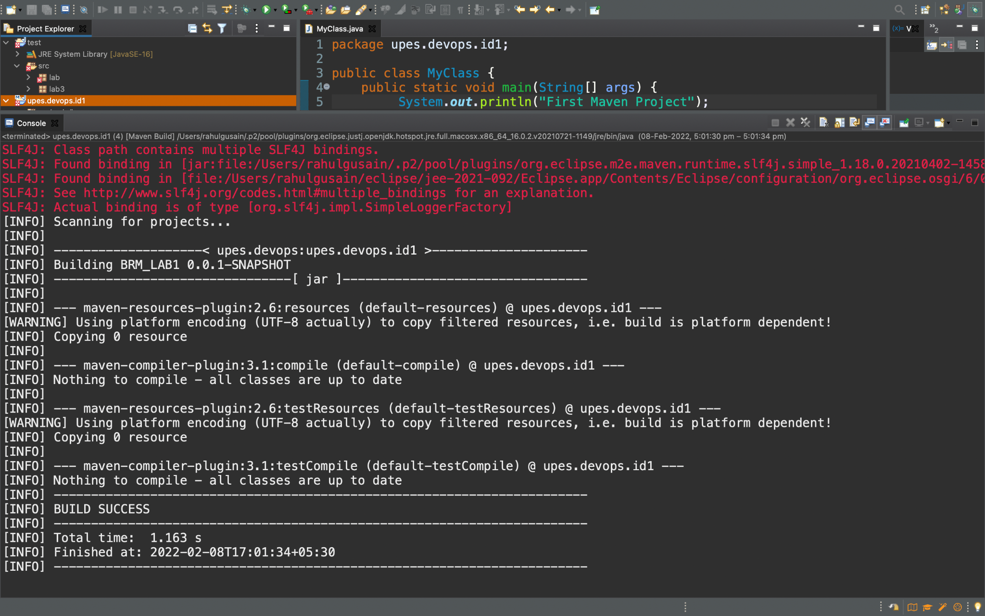

**D) Install**

Similarly, we will set​​ install as a goal and it executes BUILD SUCCESS

